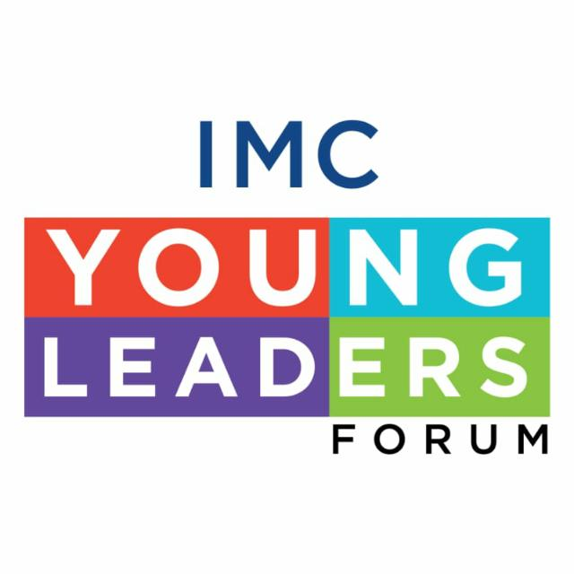
“Odyssey” Kal, Aaj aur Kal-
“Investment Options for Retail Investors:
Traditional Investment Options vs New Age Investment Options”
Saturday, October 23 2021, at 11:00 a.m. to 12:00 noon

Dear Sir/Madam,

In our constant endeavor to empower young leaders, professionals & students via various training programs & enrichment courses to equip them with the current trends & provide a global over view IMC’s Young Leaders Forum is happy to bring forth to you a unique series of talks – “Odyssey” with the theme Kal, Aaj aur Kal - with renowned seasoned entrepreneurs & new age re-inventors in the same industry. The details are as under:

Topic: “Investment Options for Retail Investors: Traditional Investment Options vs New Age Investment Options”
Day and Date: Saturday, October 23 2021
Time: 11:00 a.m. to 12:00 noon
Online Platform: Zoom

With the continuous evolution, rapid change, competition & progressive world this series will focus on what is needed to survive & thrive for companies and investors today. The focus of the seminar would be on Conventional forms of Investment (Equity, Debt and Real Estate) VS the new forms (Crypto, NFTs, Startups) for retail participants.

There will be a panel discussion of eminent sector Specialist. The panel of Speakers are:
- Ms. Aditi Kothari Desai, Director, DSP Investment Managers Private Limited (DSPIM).
- Mr. Nimesh Kampani, Cofounder & Ceo TRICA - a LetsVenture company
- Mr. Sandeep Baid, Co-Founder, Vartul Solutions (Multipie)
- Mr. Sidharth Sogani, CEO - CREBACO Global Inc

Moderated by Mr. Abhishek Murarka - VP-Community, Multipie

We extend a cordial invite to you for the event. Kindly note there is NO PARTICIPATION FEE. However, registration is mandatory. On receiving the registration details, the VC details will be provided. For registrations and other details please contact Ms. Anita Naik at anita.naik@imcnet.org or visit IMC website: https://www.imcnet.org/events-1321.

We also request you to disseminate the Webinar information amongst your Members, Associates, Affiliates and other important stakeholders who wish to benefit from this interactive session.

We do hope you will be able to seize this opportunity and participate in this event by registering.

We look forward to your valued participation.

Ajit Mangrulkar
Director General

